1. First, we install bcrypt library.

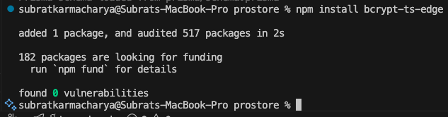

1. Then we create new 2 users as admin and regular user

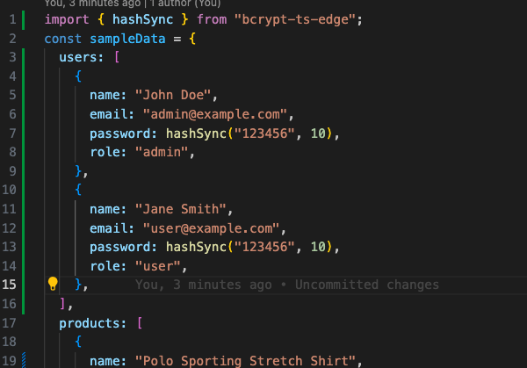

1. Then update our seeder

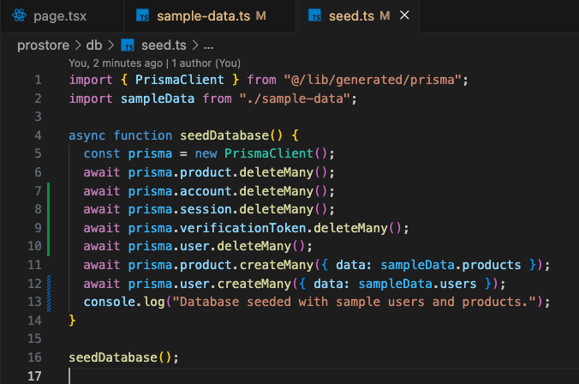

1. Then run the seeder command

1. And now we have the dummy user

